Assignment 6:
Suyash Damle
15CS10057

NOTE:

The data given in the assignment doesn’t appear to make much sense. The data has the stock prices (each observation comprising of opening value,closing value and high value) of one company’s stock for some date a large number of times. Further, the value of the stock for any company is not given for more than a few consecutive days (usually, just once). So, the data-set basically contains a large number of observations for one date for one stock, and no value for this stock at a later date.

Either there is some error introduced in the data during sanitization, or there is some serious flaw in my understanding of the dataset.

Hence, I am making the following simplifying assumptions:

ASSUMPTIONS & SIMPLIFICATIONS:

- The column corresponding to names has been ignored
- The data corresponding to certain date has been aggregated
- The observations with missing values have been neglected

At the end of this preprocessing phase, 94 observations are left for distinct values of date. These alone have been used for further process.

PROCESS

We have to predict the future value of a stock using the given data. This is the task of time – ordered data analysis. Hence, Autoregression is a viable technique. Hence, the data is now used with the standard r function for autoregression:

ar(data,method="yule-walker").

The function returns a trained model on the yule-walker algorithm. The model could then be used to obtain the predictions for any given data.

The trained model is diplayed:

Call:
ar(x = data, method = "yule-walker")

$ar
, , 1

Date x
Date 0.9735 0.02944
x -0.0896 -0.05637

$var.pred
Date x
Date 720.8 -110.8
x -110.8 2258.5
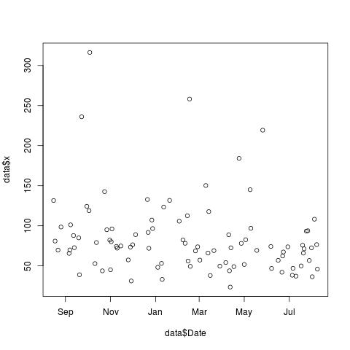
PROBLEMS IN THE FINAL MODEL:
The model, having been trained on not contiguous data could not give proper prediction if the provided test data is not spaced same as the training data

